SIMATS ENGINEERING
ASSESSMENT TOOL 1
COURSE NAME: COMPUTER NETWORKS
COURSE CODE: CSA07
COURSE OUTCOME COVERED
CO2: Configure IP addressing schemes, subnetting, and basic routing techniques using simulation tool, for efficient network design and topology. _{(BL3)}
Assessment Tool Weightage: 40%
Annexure A
ANALYTICAL PROBLEM SOLVING
- A university network is assigned the IP address block 192.168.20.0/24 for its internal communication. The network administrator has decided to divide this network into subnets for three different labs using fixed subnet masks. Lab A is assigned a /26 subnet, Lab B is assigned a /27 subnet, and Lab C is assigned a
/28 subnet. Based on the given subnet masks, apply subnetting concepts to determine the network address of each lab. Further, identify the valid range of host IP addresses and the broadcast address for each subnet. Finally, calculate the total number of usable host IP addresses available in each lab’s subnet.
- A network administrator has configured two systems with the following details: System 1 has IP address 192.168.1.130 with subnet mask 255.255.255.192, and System 2 has IP address 192.168.1.190 with subnet mask 255.255.255.192. Using the given configuration, apply subnetting techniques to determine the subnet range, network address, and broadcast address for each system. Identify the valid host IP range for both subnets based on the given subnet mask. Calculate whether each IP address falls within its respective subnet range. Also, determine the number of usable host addresses available in each subnet.

- An organization has been allocated the IP block 172.16.0.0/16 for its internal network. The network administrator has already decided the subnet masks for each department as follows: HR → /25, Sales → /26, IT → /27, and Admin → /28. Using the given subnet masks, apply subnetting techniques to assign suitable subnet addresses for each department. Determine the network address, valid host IP range, and broadcast address for each subnet. Based on the allocation, calculate the number of usable host addresses in each department. Finally, identify the remaining unused IP address range within the given network block.
- A company uses the IP address 172.16.10.0/24 and has implemented subnetting using a /27 subnet mask for its internal departments. Using the given subnet mask, apply subnetting techniques to calculate the total number of subnets created and the number of usable hosts per subnet. Determine the subnet to which the IP address 172.16.10.78 belongs. Identify the network address and broadcast address for that subnet. Also, determine whether the IP address 172.16.10.95 falls within the same subnet range based on the given configuration.
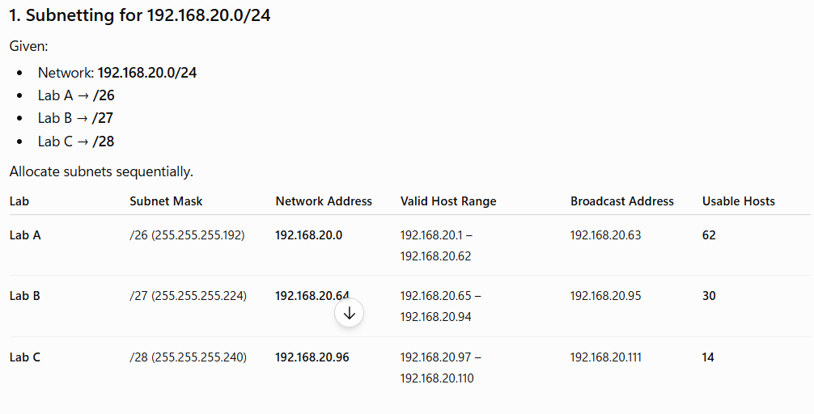
- A network uses the Internet Protocol version 6 address 2001:0db8:0000:0000:0000:ff00:0042:8329. Apply IPv6 addressing rules to compress the given address into its shortest form and then expand the compressed address back to its full notation. Using a prefix length of /64, determine the network prefix of the given address. Also, calculate the total number of possible host addresses available within this network based on the given prefix length.
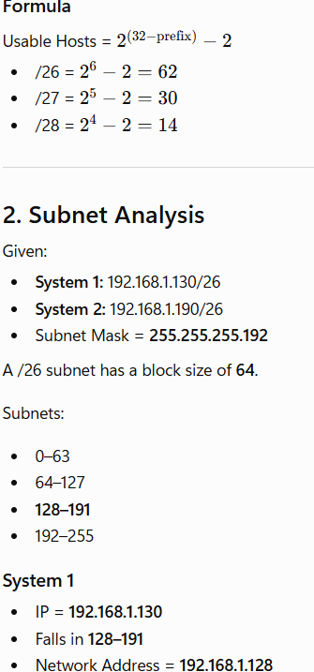
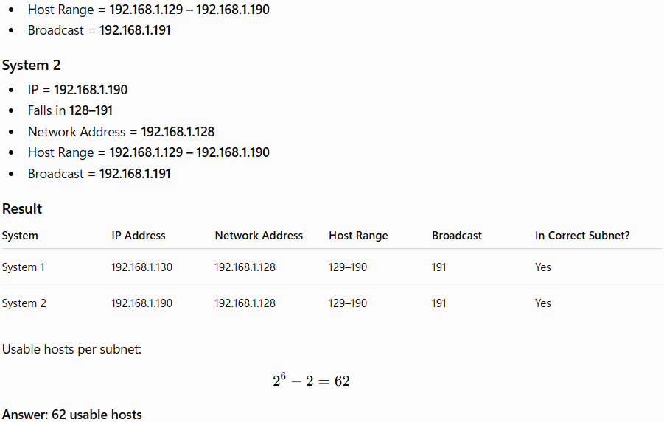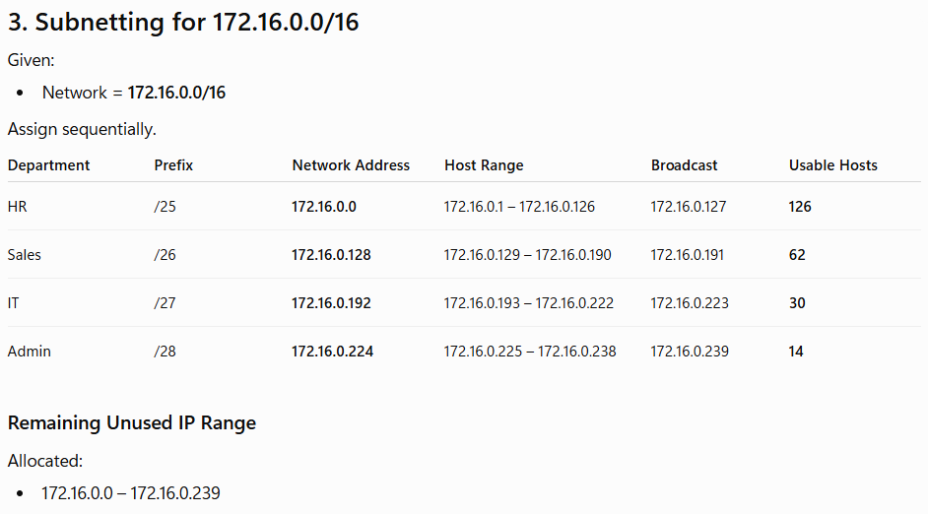
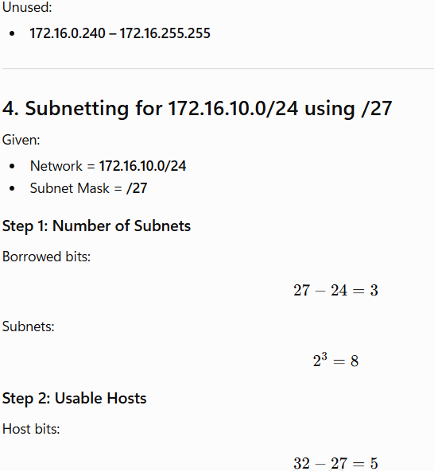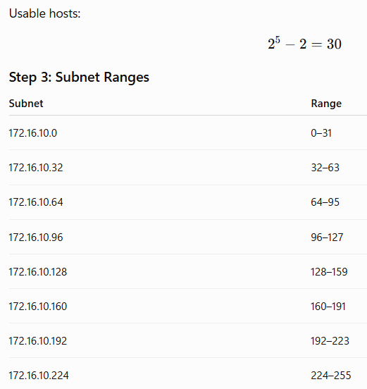
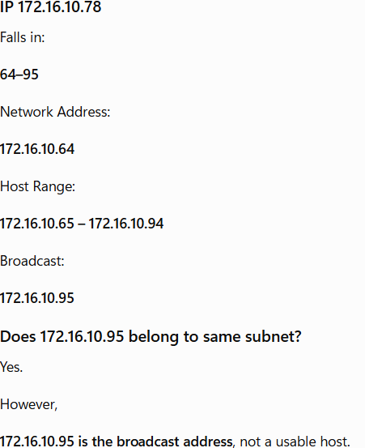
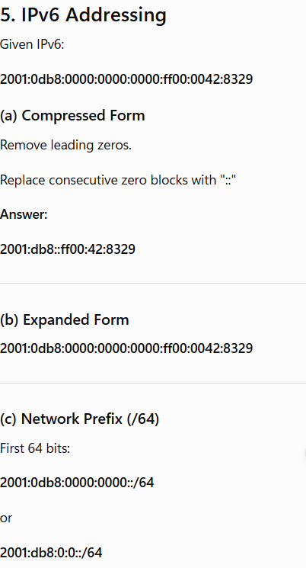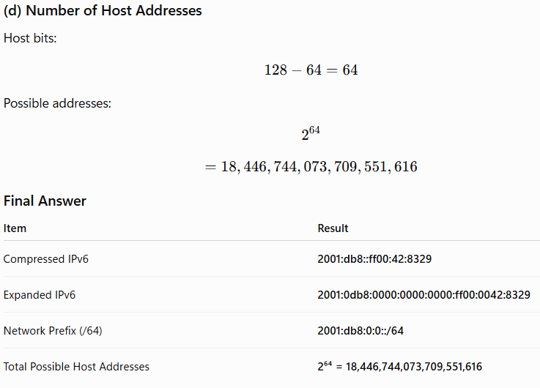
RUBRICS FOR CALCULATION
Criteria | Weightage | Level 4 (Exemplary) | Level 3 (Proficient) | Level 2 (Developing) | Level 1 (Beginning)
Problem Understanding | 20% | Clearly interprets problem,  identifies all parameters and  requirements  accurately | Understands problem with minor gaps | Partial understanding; misses key elements | Misinterprets or unable to  understand  problem
Method Selection | 20% | Selects most appropriate  method/formu  la with strong  justification | Selects correct  method with minor errors | Inappropriate or partially  correct method | Unable to select method
Solution Process | 25% | Logical, systematic  steps with correct  approach throughout | Mostly correct steps  with minor mistakes | Disorganized steps; multiple errors | No clear process
Accuracy of Calculation | 20% | All calculations accurate;  correct final answer | Minor calculation errors | Frequent errors;  incorrect final answer | No valid calculations
Interpretation of Results | 15% | Clearly interprets  results with units and  engineering relevance | Basic interpretation  with minor omissions | Limited or unclear interpretation | No  interpretation

